**NAME: KSHITIJ GUPTA**

**Enrolment Number: 21162101007**

**Sub: CS**

**Practical – 4[Batch-71]**

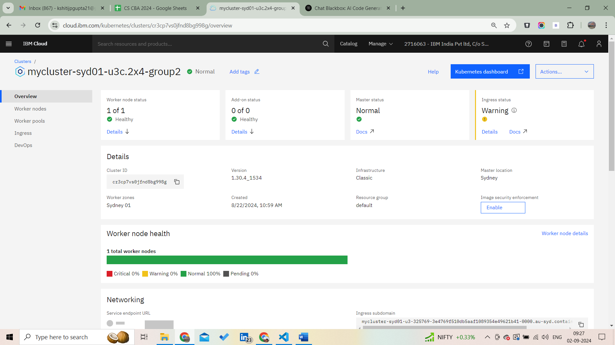

**Step-1: create the image**

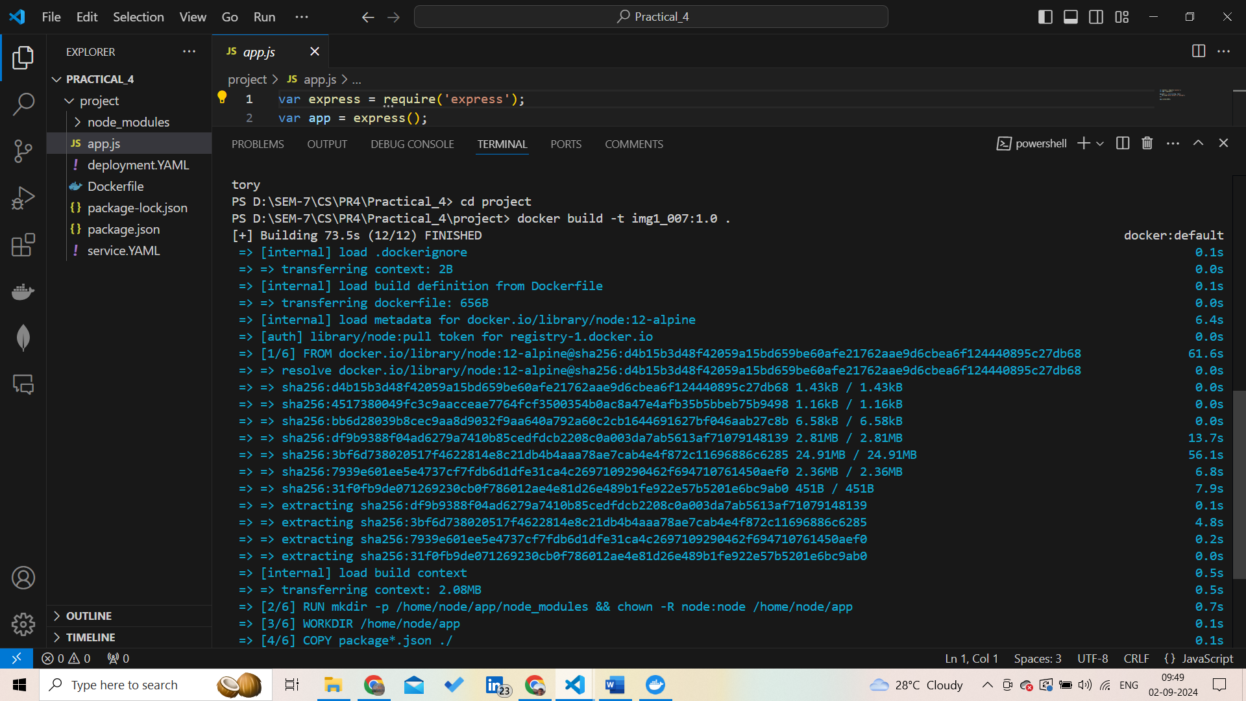

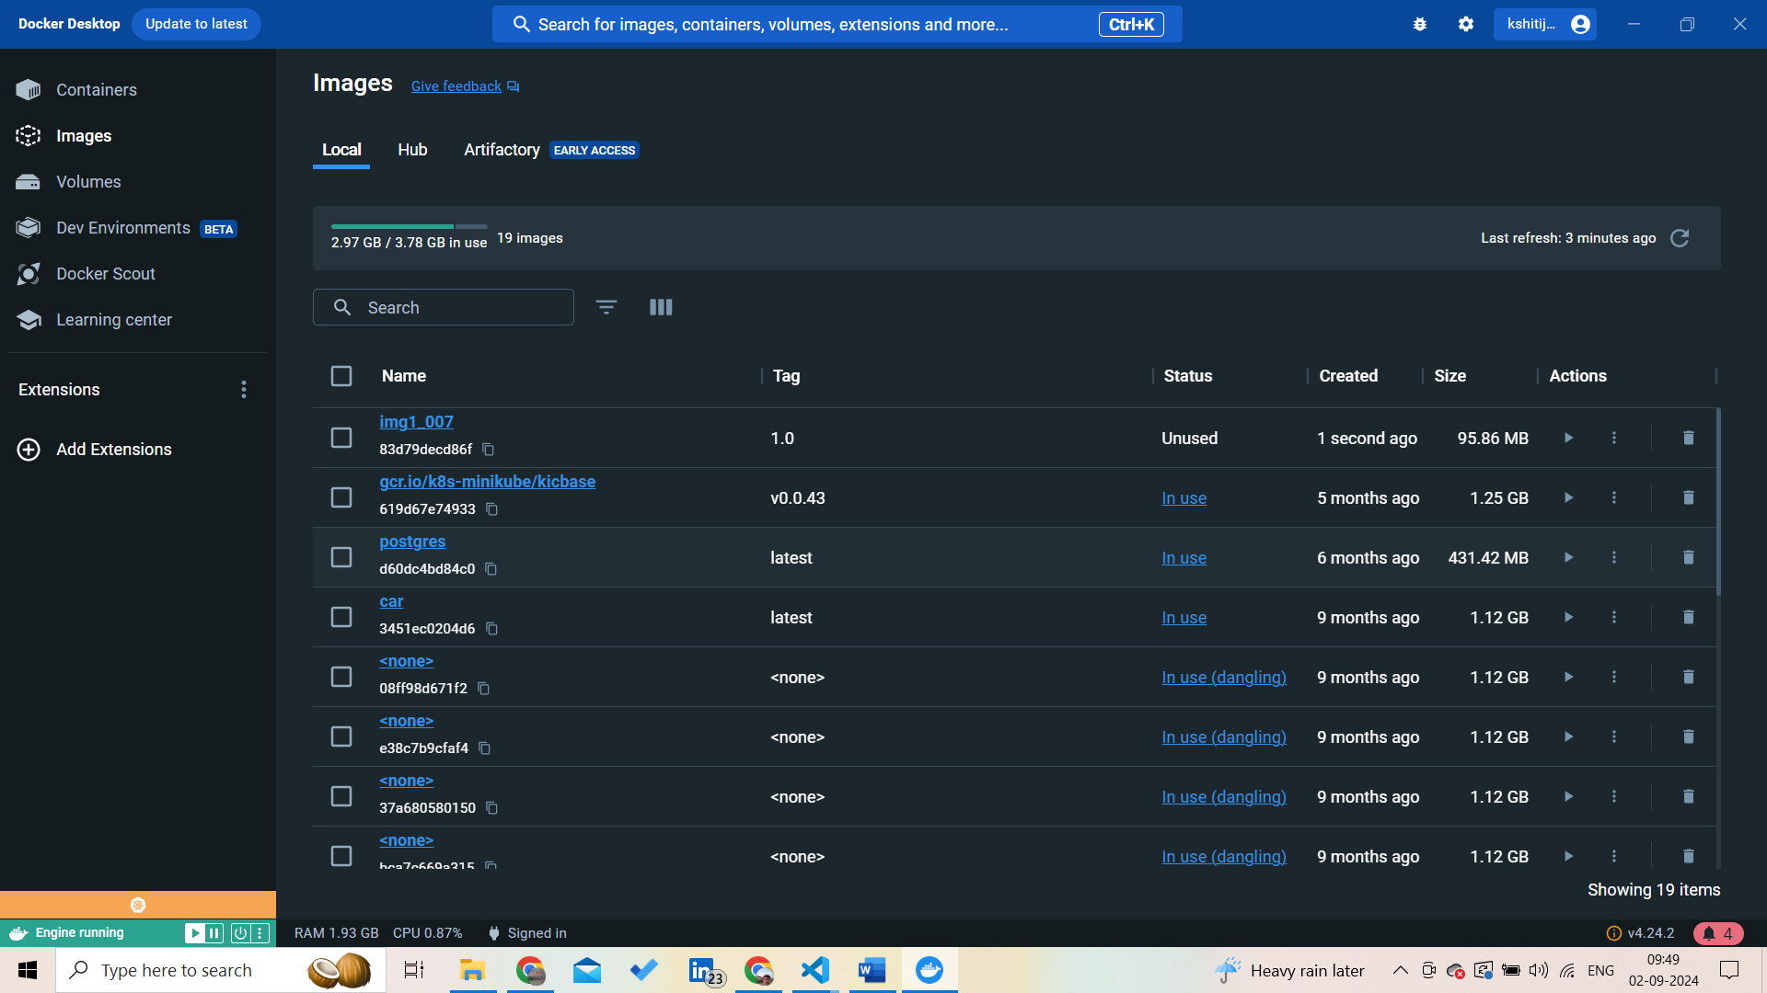

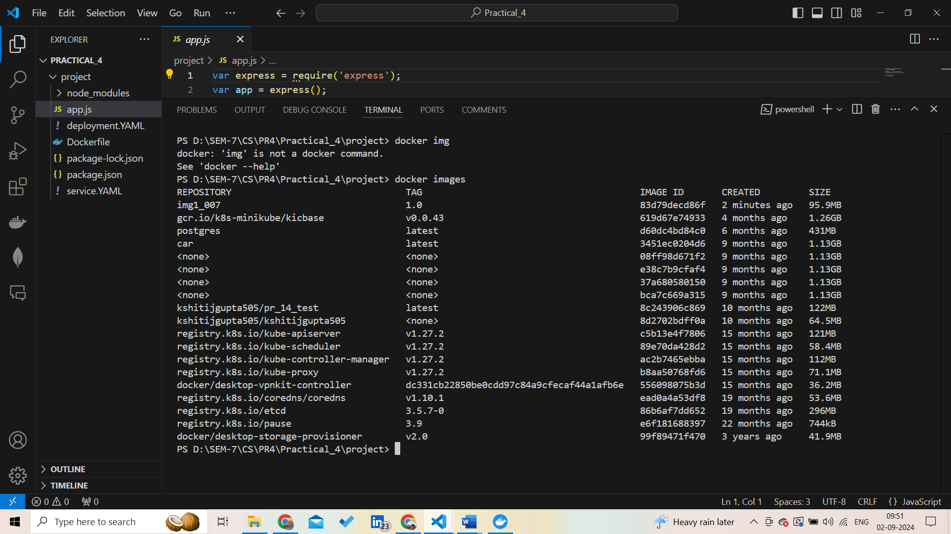

**Step-2: create the container and deploy it**

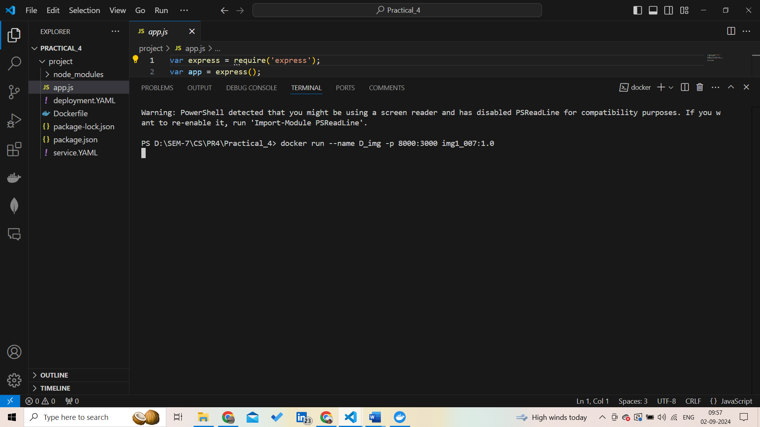

**Verify using Docker: docker run --name D_img -p 8000:3000 img1_007:1.0**

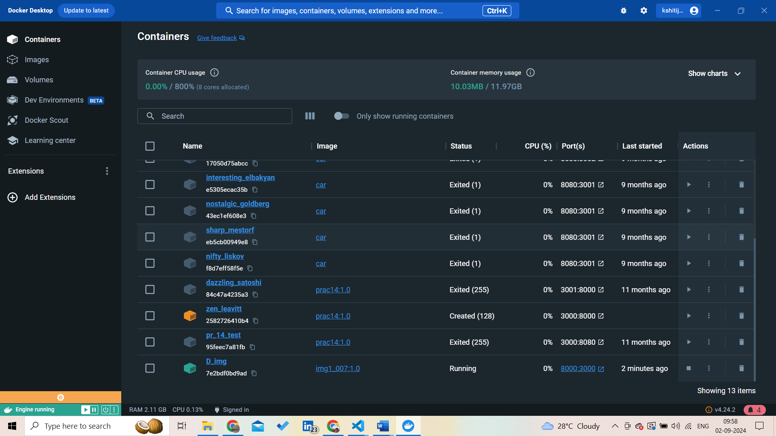

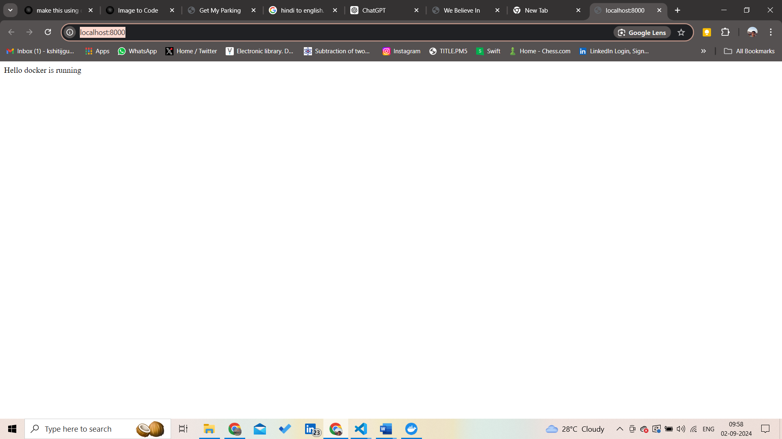

**Cheak list of container:**

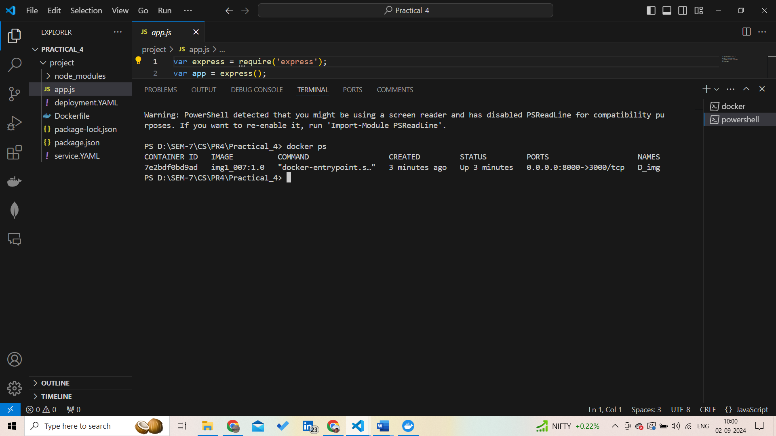

**Step-3: login through cli**

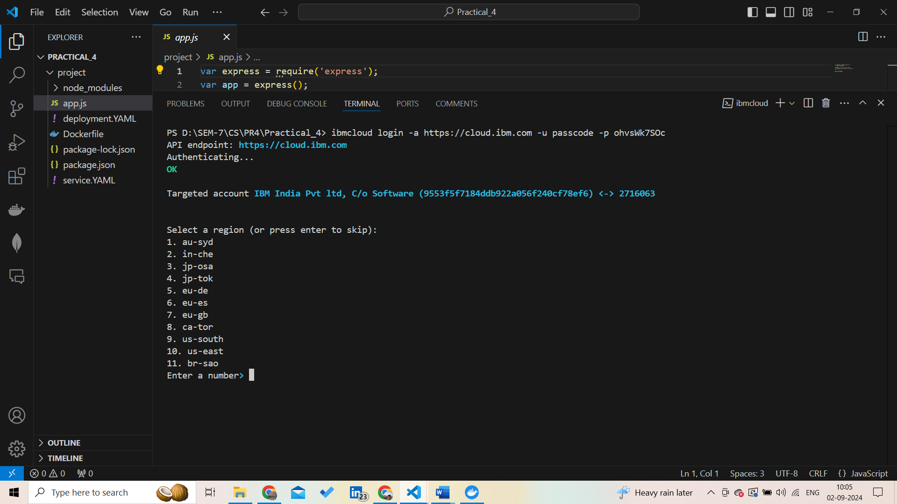

**Select the region:**

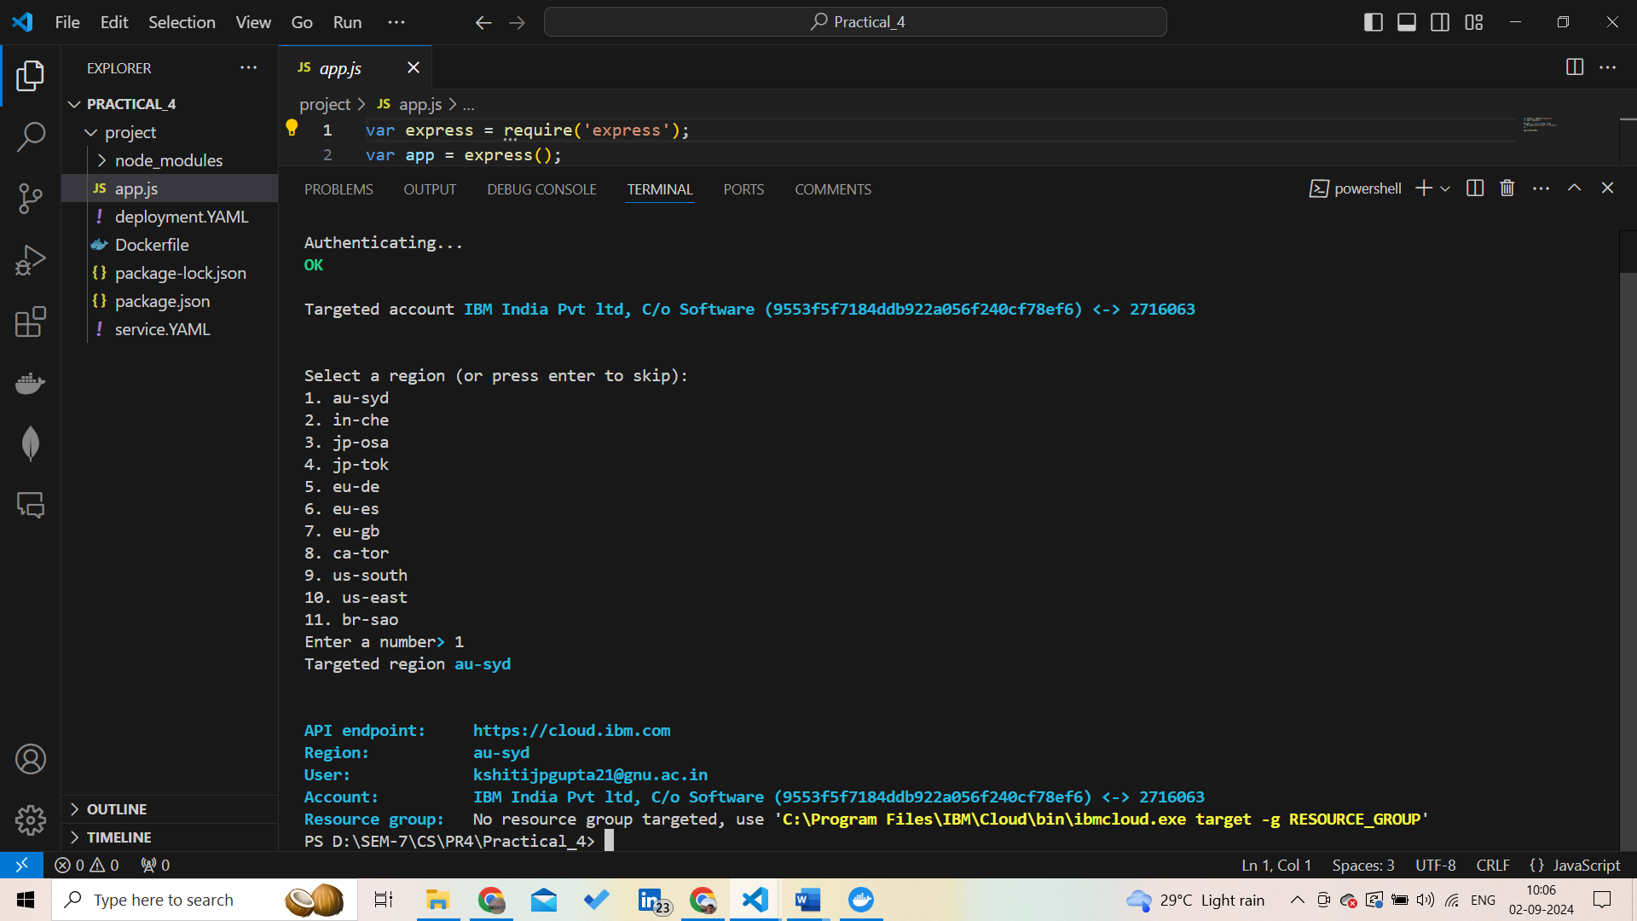

**Install some required plugins for work with container registry and kubernetes service:**

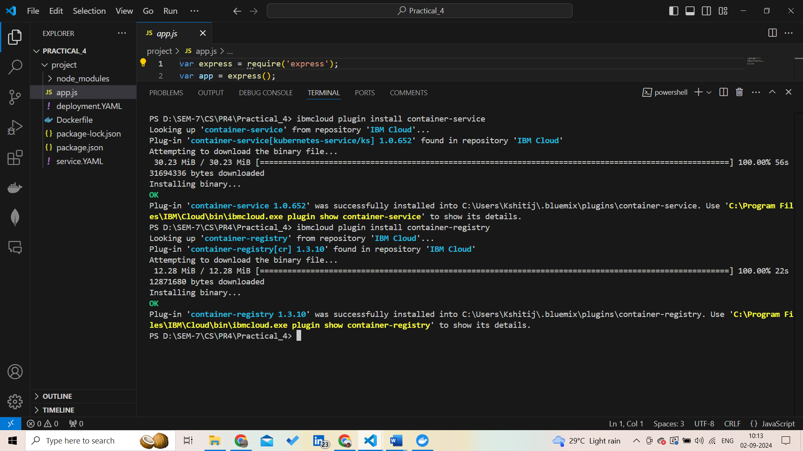

**Set Target:**

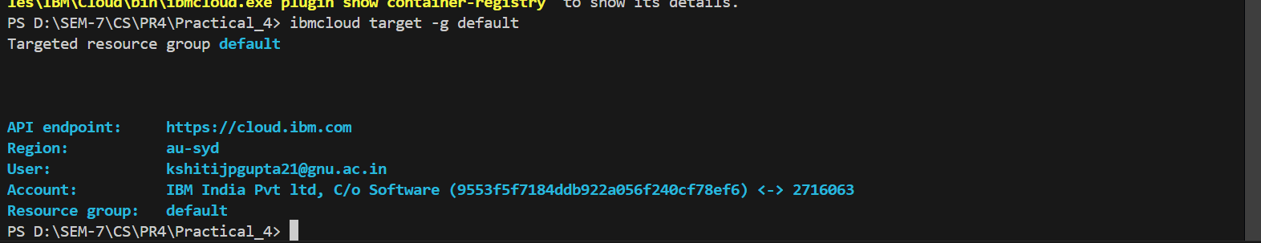

**Download kubernetes cluster configuration (for this we need cluster ID), WE get once create service on cloud**

Command: ibmcloud ks cluster config –cluster c_id

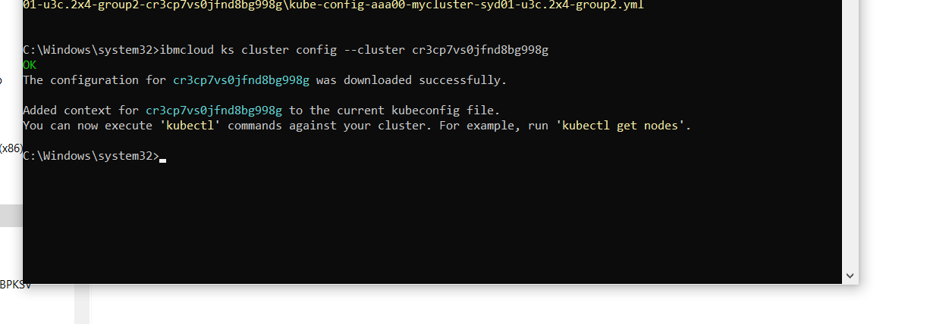

**Run command to check configuration of cluster with which we are going to work:**

Command: kubectl config current-context

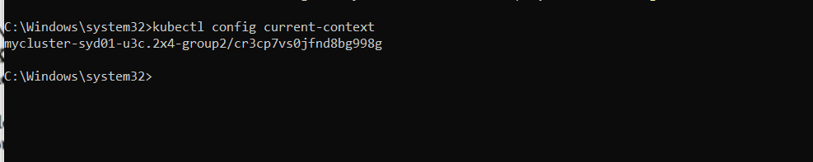

**create namespace in container registry run the command(to register container):**

command: ibmcloud cr namespace-add kshitijname

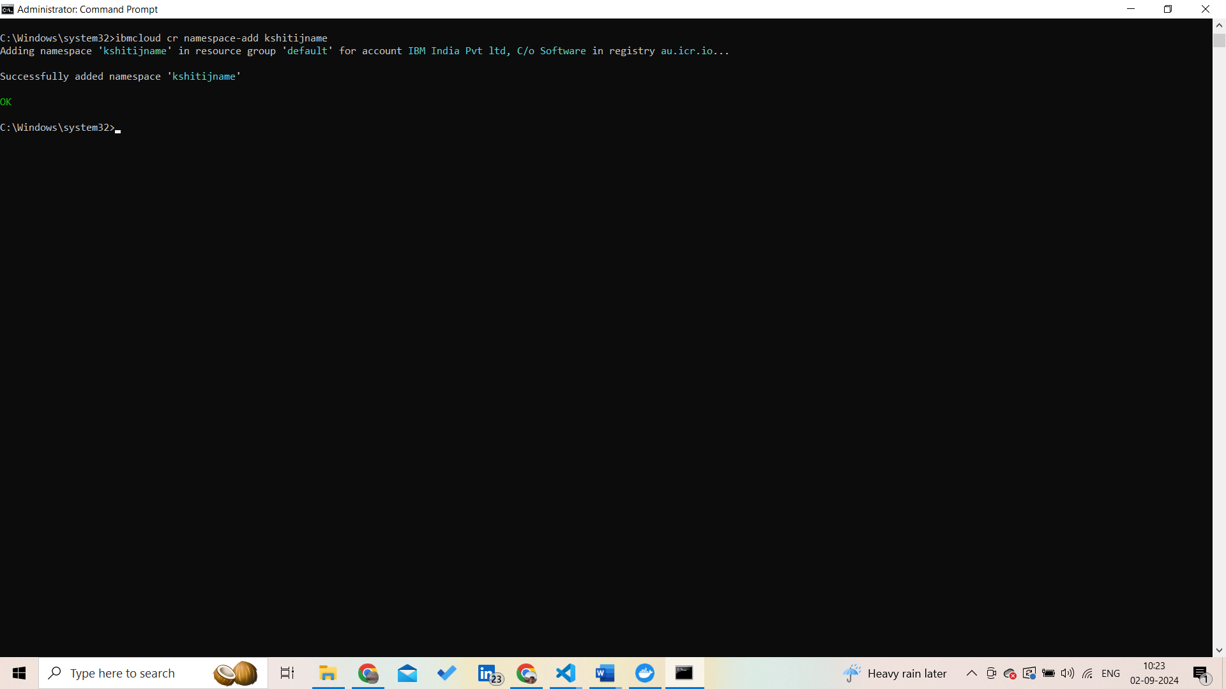

**Login into name space:**

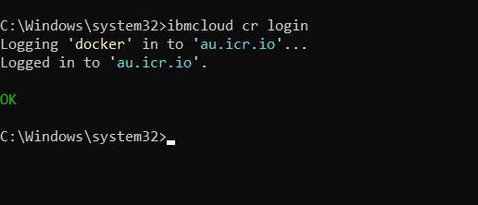

**Cheak the name space:**

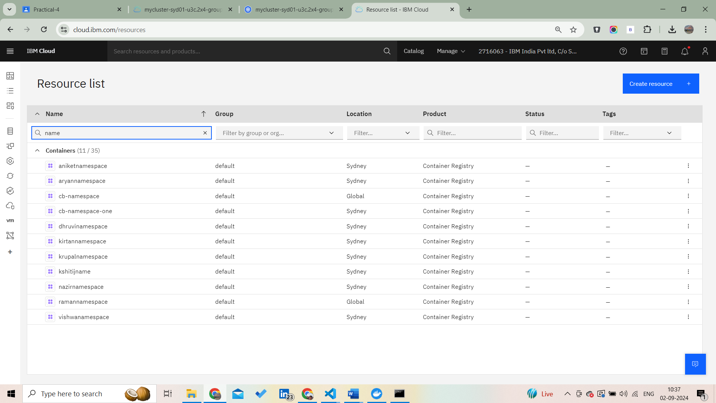

**Cheak the image:**

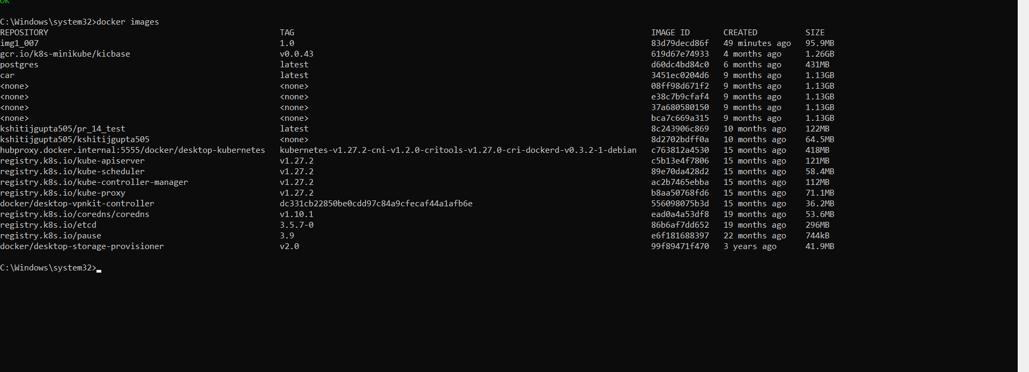

**Tag the image:**

**docker tag img1_007:1.0 au.icr.io/kshitijname/new_img_007:1.0**

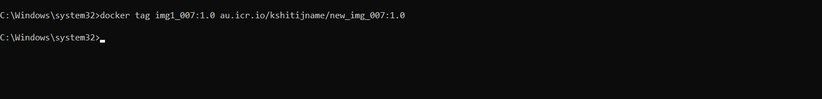

**Push the image:**

**docker tag img1_007:1.0 au.icr.io/kshitijname/new_img_007:1.0**

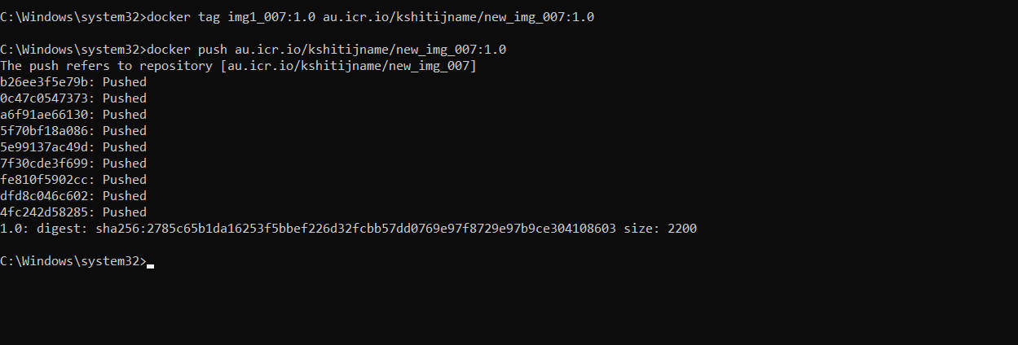

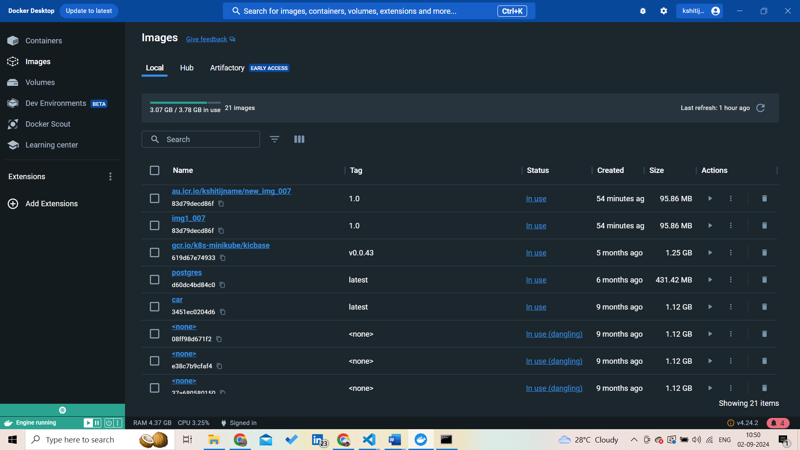

**Time to Deployment:**

**Configure the deployment.yaml:**

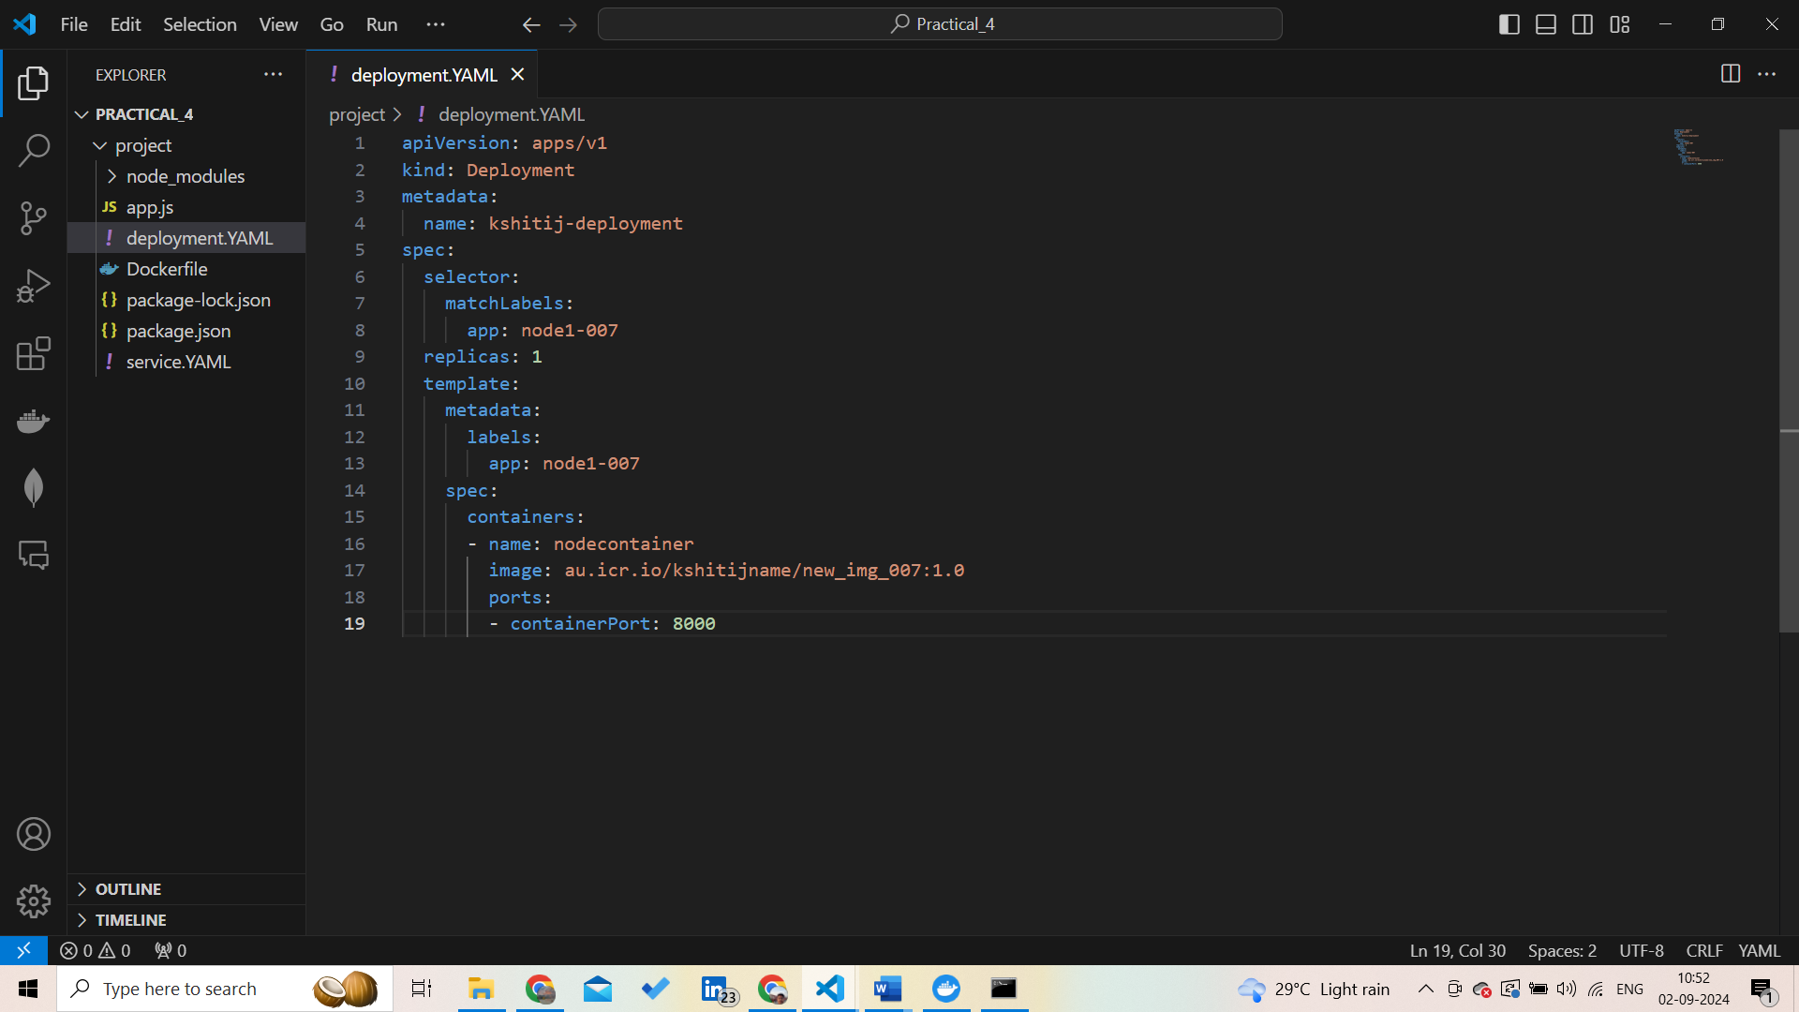

**Service.yaml:**

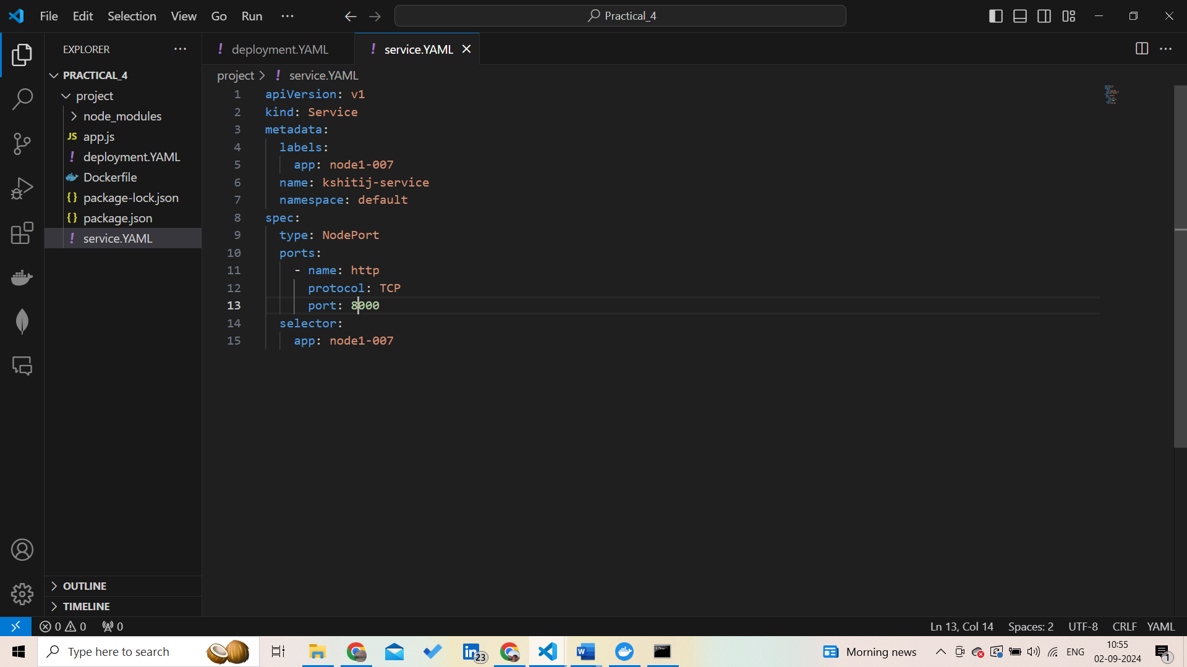

**Run command to check deployments:**

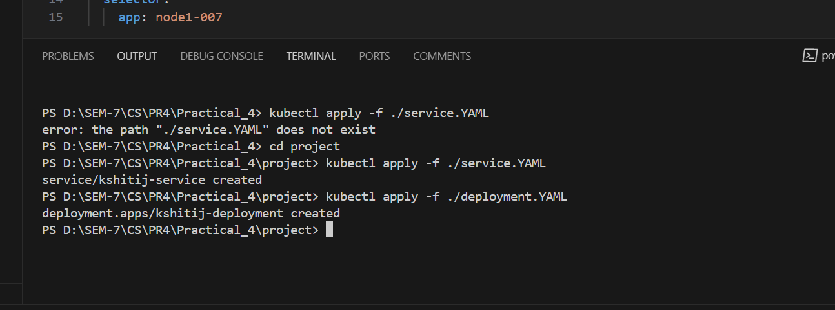

**Cheak the deployment:**

